Scientists found a 5,700-year-old piece of used gum in a lagoon - and sequenced the entire genome of the woman who chewed it
Aylin WoodwardDec 18, 2019, 00:37 IST
A boy experiences what it's like to be an ancient hunter-gatherer at the Archeon Museum Park in the Netherlands, 2016.Hans Splinter
- Archaeologists found a 5,700-year-old wad of 'chewing gum' - a piece of birch tree pitch - in Lolland, Denmark.
- The chewed bark contained ancient DNA from a hunter-gatherer woman. Scientists were able to sequence her entire genome.
- Hunter-gatherers used birch pitch as glue to make stone tools, and they may have chewed the pitch for fun, to suppress hunger, or to alleviate toothaches.
- Researchers were also able to extract genetic information from ancient germs present in the gum.
- Visit Business Insider's homepage for more stories.
Nearly 5,700 years ago, a woman followed up a meal of hazelnuts and duck with an after-dinner trick many of us still use today: she chewed a piece of gum.
Specifically, this human ancestor chewed on a piece of birch pitch - a gooey, heated version of bark from a birch tree.
The ancient hunter-gatherer woman then threw the chewed birch into a salty lagoon in what is now Lolland, Denmark, where it sat in the mud until a team of archaeologists uncovered it last year.
According to a study published today in the journal Nature Communications, scientists were able to use that wad of "chewing gum" to extract an unprecedented amount of DNA and sequence an entire ancient human genome. This was the first time that's ever been done using any fossilized material other than human bones.
The genetic analysis offers countless clues about who this woman was, what she liked to eat, and which germs plagued her mouth and gums.
"That's quite cool. We can learn so much from a whole genome: population history, physical traits, and phenotypic traits," geneticist Hannes Schroeder, who led the research, told Business Insider. "It's a richness of information that we are able to pull out of this inconspicuous chewing gum."

A dark-haired woman named Lola
The analysis revealed that the person who chewed the 2-centimeter-long piece of gum was a female with dark skin, dark hair, and blue eyes.
The study authors named the woman Lola.
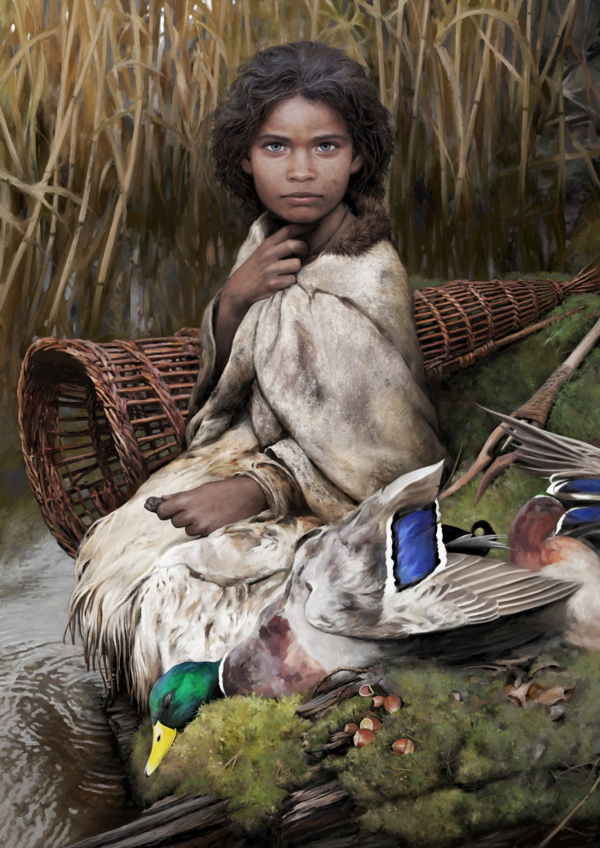An artistic reconstruction of Lola, a hunter-gatherer who lived in Europe 5,700 years ago and chewed birch pitch.Tom Björklund
They determined that her genes were more closely related to hunter-gatherers from mainland Europe than groups that lived in Scandinavia at the time. That tells archaeologists about how Denmark got populated, Schroeder said: "It looks like, when south Denmark was first settled, it happened from the south."
In other words, the study lends support to the idea that hunter-gatherers moved north from modern-day Germany into Syltholm, an ancient village on Lolland island off the southern coast of Denmark, rather than west from nearby Sweden.
Given fossil evidence found near the chewing gum, scientists also figured out that Lola's village seemed to rely primarily on fishing and hunting for sustenance. Bones from cattle, deer, and otters were deposited near Syltholm, alongside remnants of fish traps.
These ancient humans also gathered nuts and berries. In the gum, Lola's DNA was accompanied by DNA from hazelnuts and mallard ducks. According to the study authors, that shows Lola had recently munched on these foods.

Birch gum and glue
Birch pitch is made by heating birch bark. Ancient hunters used the pitch, a form of tar, as an adhesive to glue arrowheads onto arrows and affix stone blades onto wooden handles.
Schroeder said ancient birch pitch samples often have small teeth marks from children - suggesting the tar could have been something to gnaw on "recreationally."
"Maybe, just like kids today, it was a type chewing gum," he said. "Having said that, it's not sweet like chewing gum today."
Schroeder said he's never tasted birch pitch himself, but assumes it has a bitter taste.
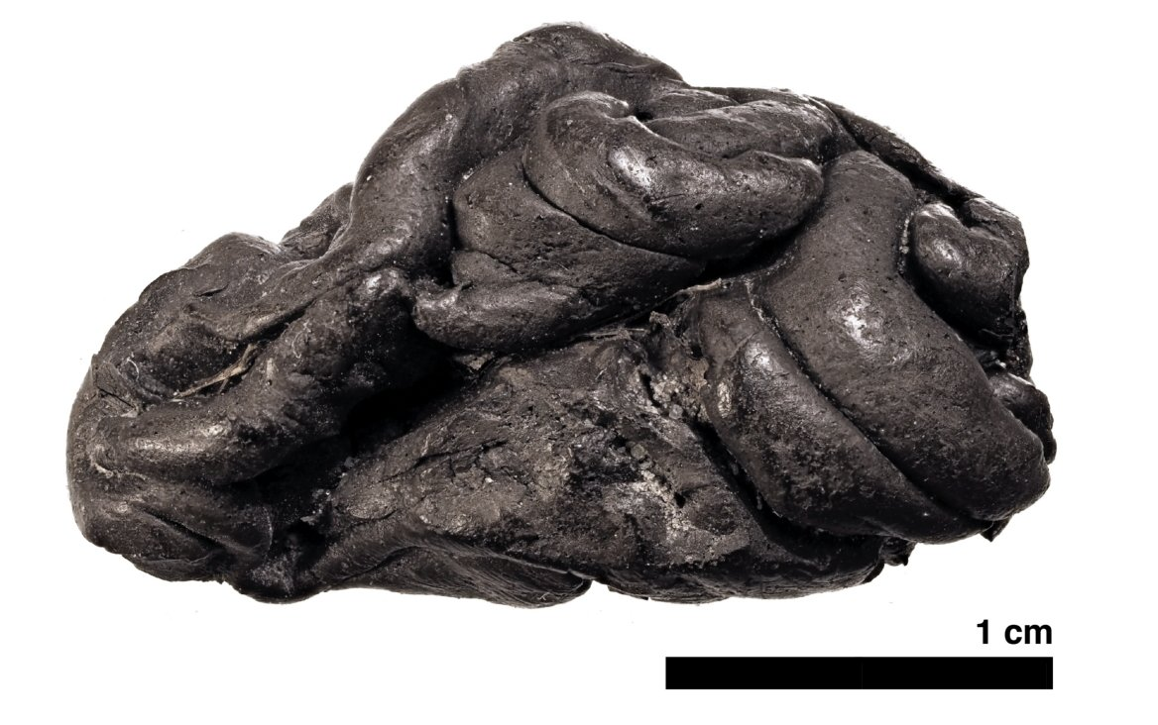A piece of birch pitch from Syltholm, southern Denmark.Theis Jensen
The tar may also have had antiseptic or antibacterial properties, he said.
"People have also suggested other uses, like alleviating toothaches or suppressing hunger," Schroeder added.

Ancient germs trapped in gum
Schroeder and his team were also able to analyze the genes of 40 mouth microbes and pathogens that were preserved in the pitch.
They detected bacteria like Porphyromonas gingivalis, a germ that can cause gum disease, and Streptococcus pneumoniae, which is linked to pneumonia. The gum wad also included genetic traces of the Epstein-Barr virus (EBV), which is known to cause mononucleosis.
"Now we can look at evolution of specific pathogens, like EBV, and how these bugs change in terms of their virulence," Schroeder said. "To be able to get these ancient pathogens' genomes allows you to see how they evolved and spread."
The presence of these bacteria doesn't necessarily mean Lola was sick, though, since the germs can be present in a person without causing illnesses.
A 3D illustration of Porphyromonas gingivalis bacteria.Kateryna Kon/Shutterstock
The discovery could, however, help scientists better understand how germs change over thousands of years, and could further evolve in the future.

